Relationship Quick Check - 10 Questions

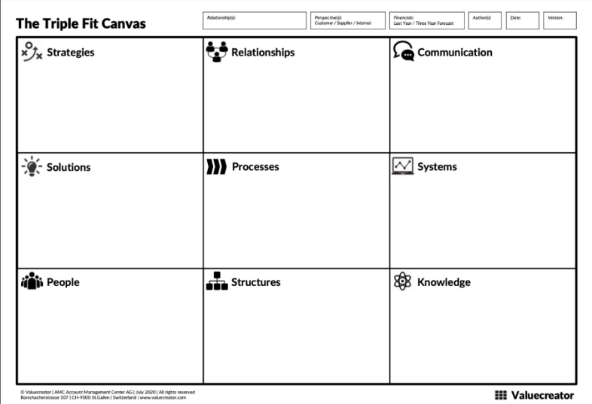
In our continuous attempt to be a good partner we would like to evaluate our business relationship with you and get a 360-degree perspective on the value drivers making up such an affiliation.
The Triple Fit Canvas as shown in the picture is a proven tool to assess relationships and to help discover and develop beneficial aspects to create additional mutual value for the future.
To evaluate how close we are in our relationship, we would like you to quickly answer the 10 questions below, thus rating our "performance" in handling it. 1 being the lowest, 5 being the highest rating.
This will constitute the starting point of a new process to discuss further mutually beneficial actions based on a better understanding of your needs and expectations, and beyond.
We are looking forward to receiving your rating and the discussion emerging from it. Thank you.
[ABC]

Company / Department: …..…………………………………………………………………………………………………………….
 | Overall, we rate our relationship with partner [ABC] as | 1 - 2 - 3 - 4 - 5
 | - Partner [ABC] has a clear three-year vision and collaboration strategy for us | 1 - 2 - 3 - 4 - 5
 | - Partner [ABC] develops unique offerings and value propositions for us | 1 - 2 - 3 - 4 - 5
 | - Partner [ABC] assigns people with the ability to act as trusted advisors for us | 1 - 2 - 3 - 4 - 5
 | - Partner [ABC] maintains strong contacts from operational to executive level with us | 1 - 2 - 3 - 4 - 5
 | - Partner [ABC] aligns processes effectively and efficiently along our value chain | 1 - 2 - 3 - 4 - 5
 | - Partner [ABC] enables cross-functional organization and support structures for us | 1 - 2 - 3 - 4 - 5
 | - Partner [ABC] interacts in an open, fair and forward-looking way with us | 1 - 2 - 3 - 4 - 5
 | - Partner [ABC] steers business with us via compatible IT systems and joint KPI’s | 1 - 2 - 3 - 4 - 5
 | - Partner [ABC] uses its knowledge to create new, profitable business for us | 1 - 2 - 3 - 4 - 5

